**Arduino beginning:**

Hghghh

**Trial :- to check USB accessibility**

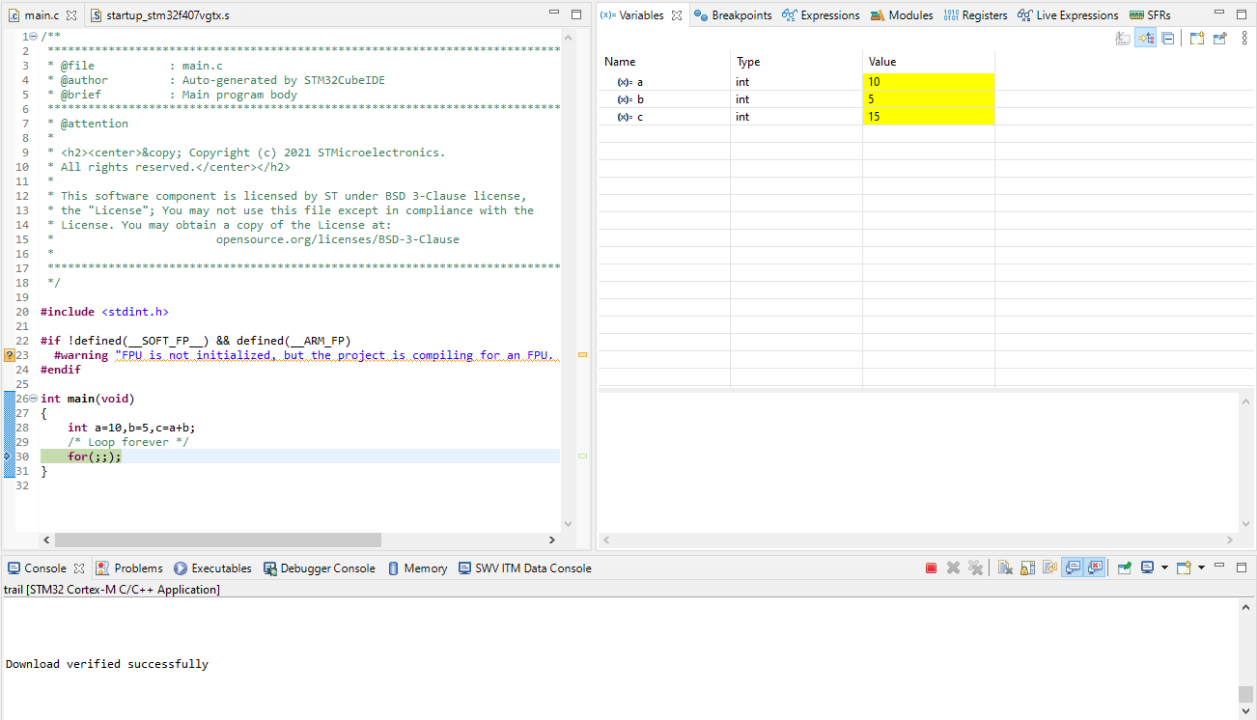

**#include** <stdint.h>

**#if** !defined(__SOFT_FP__) && defined(__ARM_FP)

**#warning** "FPU is not initialized, but the project is compiling for an FPU. Please initialize the FPU before use."

**#endif**

**int** **main**(**void**)

{

**int** a=10,b=5,c=a+b;

/* Loop forever */

for(;;);

}

**Hello world program:**

**#include** <stdint.h>

**#if** !defined(__SOFT_FP__) && defined(__ARM_FP)

**#warning** "FPU is not initialized, but the project is compiling for an FPU. Please initialize the FPU before use."

**#endif**

**#include** <stdio.h>

**int** **main**(**void**)

{

**printf**("Hello World\n");

**for**(;;);

}

//////for building and debugging library, basically to display data of microcontroller to the console using SWV library

**#include** <sys/stat.h>

**#include** <stdlib.h>

**#include** <errno.h>

**#include** <stdio.h>

**#include** <signal.h>

**#include** <time.h>

**#include** <sys/time.h>

**#include** <sys/times.h>

/////////////////////////////////////////////////////////////////////////////////////////////////////////

// Implementation of printf like feature using ARM Cortex M3/M4/ ITM functionality

// This function will not work for ARM Cortex M0/M0+

// If you are using Cortex M0, then you can use semihosting feature of openOCD

/////////////////////////////////////////////////////////////////////////////////////////////////////////

//Debug Exception and Monitor Control Register base address

**#define** DEMCR *((**volatile** uint32_t*) 0xE000EDFCU )

/* ITM register addresses */

**#define** ITM_STIMULUS_PORT0 *((**volatile** uint32_t*) 0xE0000000 )

**#define** ITM_TRACE_EN *((**volatile** uint32_t*) 0xE0000E00 )

**void** **ITM_SendChar**(uint8_t ch)

{

//Enable TRCENA

DEMCR |= ( 1 << 24);

//enable stimulus port 0

ITM_TRACE_EN |= ( 1 << 0);

// read FIFO status in bit [0]:

**while**(!(ITM_STIMULUS_PORT0 & 1));

//Write to ITM stimulus port0

ITM_STIMULUS_PORT0 = ch;

}

/* Variables */

//#undef errno

**extern** **int** errno;

**extern** **int** **__io_putchar**(**int** ch) **__attribute__**((weak));

**extern** **int** **__io_getchar**(**void**) **__attribute__**((weak));

**register** **char** * stack_ptr **asm**("sp");

**char** *__env[1] = { 0 };

**char** **environ = __env;

/* Functions */

**void** **initialise_monitor_handles**()

{

}

**int** **_getpid**(**void**)

{

**return** 1;

}

**int** **_kill**(**int** pid, **int** sig)

{

errno = EINVAL;

**return** -1;

}

**void** **_exit** (**int** status)

{

_kill(status, -1);

**while** (1) {} /* Make sure we hang here */

}

**__attribute__**((weak)) **int** **_read**(**int** file, **char** *ptr, **int** len)

{

**int** DataIdx;

**for** (DataIdx = 0; DataIdx < len; DataIdx++)

{

*ptr++ = __io_getchar();

}

**return** len;

}

**__attribute__**((weak)) **int** **_write**(**int** file, **char** *ptr, **int** len)

{

**int** DataIdx;

**for** (DataIdx = 0; DataIdx < len; DataIdx++)

{

//__io_putchar(*ptr++);

ITM_SendChar(*ptr++);

}

**return** len;

}

**int** **_close**(**int** file)

{

**return** -1;

}

**int** **_fstat**(**int** file, **struct** stat *st)

{

st->st_mode = S_IFCHR;

**return** 0;

}

**int** **_isatty**(**int** file)

{

**return** 1;

}

**int** **_lseek**(**int** file, **int** ptr, **int** dir)

{

**return** 0;

}

**int** **_open**(**char** *path, **int** flags, ...)

{

/* Pretend like we always fail */

**return** -1;

}

**int** **_wait**(**int** *status)

{

errno = ECHILD;

**return** -1;

}

**int** **_unlink**(**char** *name)

{

errno = ENOENT;

**return** -1;

}

**int** **_times**(**struct** tms *buf)

{

**return** -1;

}

**int** **_stat**(**char** *file, **struct** stat *st)

{

st->st_mode = S_IFCHR;

**return** 0;

}

**int** **_link**(**char** *old, **char** *new)

{

errno = EMLINK;

**return** -1;

}

**int** **_fork**(**void**)

{

errno = EAGAIN;

**return** -1;

}

**int** **_execve**(**char** *name, **char** **argv, **char** **env)

{

errno = ENOMEM;

**return** -1;

}

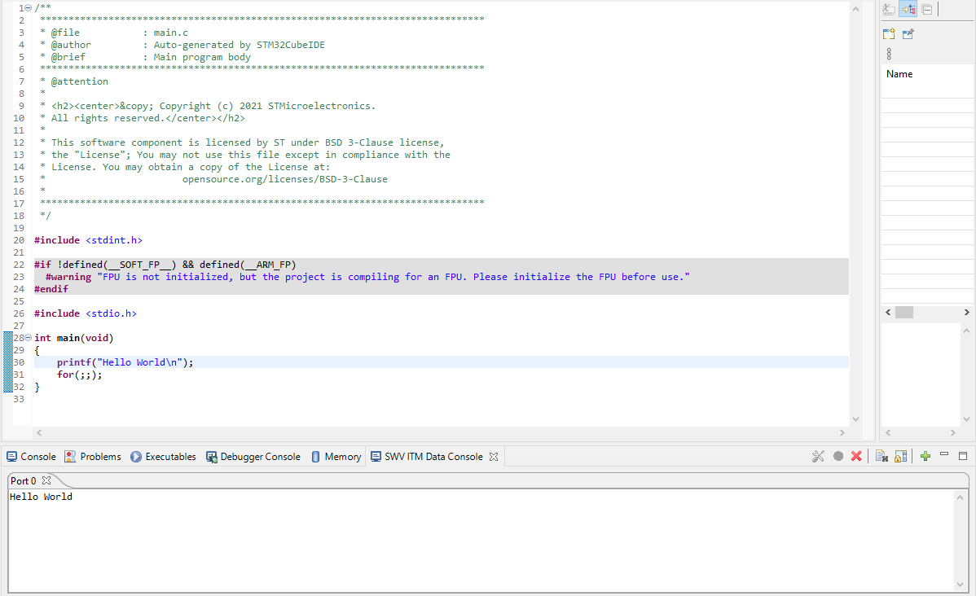

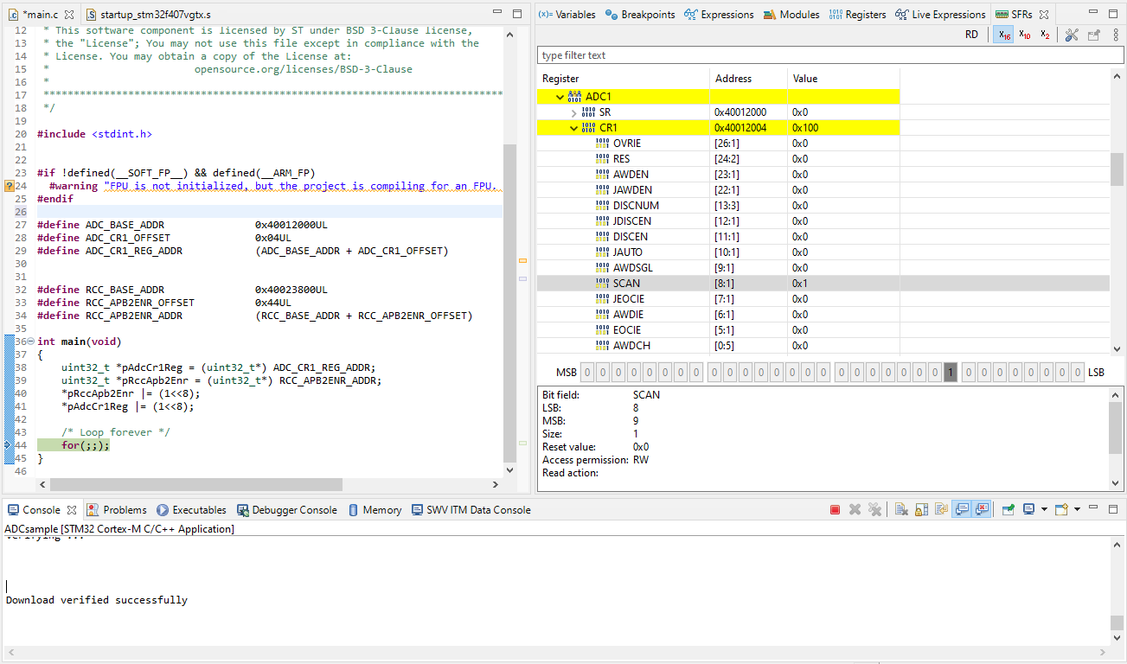

**#include** <stdint.h>

**#if** !defined(__SOFT_FP__) && defined(__ARM_FP)

**#warning** "FPU is not initialized, but the project is compiling for an FPU. Please initialize the FPU before use."

**#endif**

**#define** ADC_BASE_ADDR 0x40012000UL

**#define** ADC_CR1_OFFSET 0x04UL

**#define** ADC_CR1_REG_ADDR (ADC_BASE_ADDR + ADC_CR1_OFFSET)

**#define** RCC_BASE_ADDR 0x40023800UL

**#define** RCC_APB2ENR_OFFSET 0x44UL

**#define** RCC_APB2ENR_ADDR (RCC_BASE_ADDR + RCC_APB2ENR_OFFSET)

**int** **main**(**void**)

{

uint32_t *pAdcCr1Reg = (uint32_t*) ADC_CR1_REG_ADDR;

uint32_t *pRccApb2Enr = (uint32_t*) RCC_APB2ENR_ADDR;

*pRccApb2Enr |= (1<<8);

*pAdcCr1Reg |= (1<<8);

/* Loop forever */

for(;;);

}